4th Asia-Pacific GeoScience International Conference

Bangkok- 31-07 to 04-08-2007.

Eco-friendly, Modification of Severe Tropical Cyclone : A Theory

DEEPAK BHATT-ACHARYA
Social Worker, NGO – Orissa Research Laboratory, Studio Building, Kedar Gouri Road,
Bhubaneswar – 751002, India. oddisilab1@dataone.in - Submitted-23/01/07.

Littoral & continental land forms of the eastern Pacific and the Indian sub-continent, bi-annually experience severe tropical cyclones (STC). This creates great stress on national economies (1) of this most populous region. The Super Cyclone of 1999 & the Katrina of 2006 delivered wonton destruction & mayhem. Intensification and life of a system depends on length dimension of the cold region beyond the system’s front and of the warm regions, in the rear [‘F/H’ & ‘R/H’: Fig.1]. Author had set objective to theorise a eco-friendly mechanism to down regulate a killer system (2). During 2007, the Pacific will flip-flop between El-Nino & La-Nina episodes. This is perfect recipe for cyclogenesis. Danger time, is ahead. Author had discussed concept for down regulation (3). Civil societies & administrations can ill-afford complacency. We consider a theory on basis of known and observed physics of a STC.
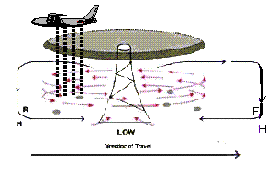
Fig. 1 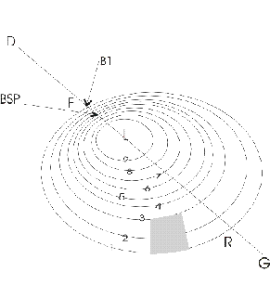 Fig. 2

STCs demonstrate crisp-boundary phenomena, with stepped, inversed, stratification of barometric pressure in dynamic stability state, high gyration, inertia, low RPM which vary along circular barometric bands (4). Fluid mechanics has been co-related with monsoon stream flows (5) and boundary layers been indicated as candidate for safe weather modification (6). Peripheral regions of a vortex have wide boundaries (weak), least RPM & relative low horizontal component of the thrust. Ideal candidate region for intervention. We propose to top seed the rear periphery ‘R’ with activated charcoal, having surface area ~2000 mt²/gm, packed in pressurized polypropylene bags in desiccated nitrogen [Fig.1]. ½ - 1 MT (per drop) initially hydrophobic, -will abruptly expand radial size at top (energy depleted clouds= Bosons), -alter ion balance, - subsequently hydrophilic, – will reduce volume\mass at lower (variably charged vapor & liquid particulates=Fermions), -trigger ultra heavy cloud to sea arching, – draw away energy to the rear from the highly energized & radio opaque axial core, - result in near creation of a neo axis of vertical turbulence, -induce up draft & down draft, -act as CCN,- formation of super sized droplets in sea location, - act as a hydro pile (wall) against the horizontal flows & dynamic wind balance, -velocity, energy, inertia, bulk mass modulus, & hydrostatic (thrust) off-balance, - internal concoction, – non synergic ‘F’, - weakening of crisp boundary conditions, – peripheral boundary layer failure, - systemic internal deregulation, - eye dissipate, etc. Down regulate the ‘T’ factor 50-100 kms. off coast, allow the system to sail inland to serve rain fed cum subsistence agriculture & ground water charging. Gray area [Fig.2] marks theoretical seeding region. Aircraft flies opposite to wind flow direction Theory, postulates, triggering meso-scale activity within a synergic synoptic system. Non decaying, limited down regulation. Mid Pacific, best experiment zone. Multi-lateral initiative is warranted. Acknowledgement : A. Acharya, N. T. University, Singapore.

References

1- D. Bhatt-acharya, “Effect Of Very Severe Cyclone : Select Perspectives”, Proceedings of TROPMET 2006, vol. I, pp. a38-39, Indian Meteorological Society, Golden Jubilee Symposium, Pune, 21-11-06.
2 - D. Bhattacharya, Few Aspects of Super Cyclone; XXIV-IIG, & International Conference, NEHU, 03-2003.
3 - D. Bhatt-acharya, Inducing Modification in a Severe Cyclonic Storm : A Theory, International Workshop on Weather Modification, JNTU, Hyderabad, 18-20th Jan. 2007.
4 - D. Bhatt-acharya, Mechanical Aspects of Tropical Cyclones, Technology for Disaster Mitigation – TECHDIM - 2006, National Engineering Conference, JITM., DST. sponsored, 27-28 /01/2006.
5 - D. Bhatt-acharya, Indian Monsoon & Polygonal Box Experiment , National Seminar on Climate Change : Challenges To Indian Cities, National Seminar, Andhra Uni., I M D & D S T sponsored, 23-25th Jan. 2006.
6- D. Bhatt-acharya, “The Orography of Orissa & Andhra Act as Hydraulic Devices vis-à-vis Monsoon Drafts : A Theory”, National Workshop on Mesoscale Modeling of Atmospheric Process, DST, Andhra Uni., 29-31 Jan, 2007.

